Future Interns - Cyber Security Task 2 (2026)

PHISHING EMAIL DETECTION & AWARENESS REPORT
Date: June 2026
Organization: Future Interns
Task: Cyber Security Task 2
Submitted By:
PATIL TEJASWINI ANIL
Objective:
Analysis of Email Headers, Identification of Phishing Indicators, Risk Classification and Security Awareness Recommendations.

Disclaimer

This Phishing Email Detection & Awareness Report has been prepared as part of the Future Interns Cyber Security Internship Program.
The purpose of this report is to analyze email samples, identify phishing indicators, evaluate email authenticity, and provide awareness recommendations to help users recognize and avoid phishing attacks.
The analysis was conducted using email headers, sender verification, SPF, DKIM, DMARC authentication records, and publicly available security analysis tools. This report is intended solely for educational and awareness purposes.
No exploitation, unauthorized access, or offensive security activities were performed during this assessment.

Scope
The assessment focuses on identifying phishing indicators within email communications through header analysis, sender verification, content inspection, and authentication validation.
Tools Used
Tool Name | Purpose
Google Header Analyzer | Email Header Analysis
MXToolbox Header Analyzer | SPF, DKIM & DMARC Verification
Gmail Original Message | Raw Header Collection
VirusTotal | URL Reputation Analysis
Browser Investigation | Domain Verification
Email Samples Included
- Internship Offer Email (Safe)
- Suspicious Email Sample
- Phishing Email Sample

Risk Classification Table

Classification | Description | Risk Level
Safe | Legitimate email with valid authentication | Low
Suspicious | Some phishing indicators present | Medium
Phishing | Multiple phishing indicators identified | High

Email Sample 1 (Overview)

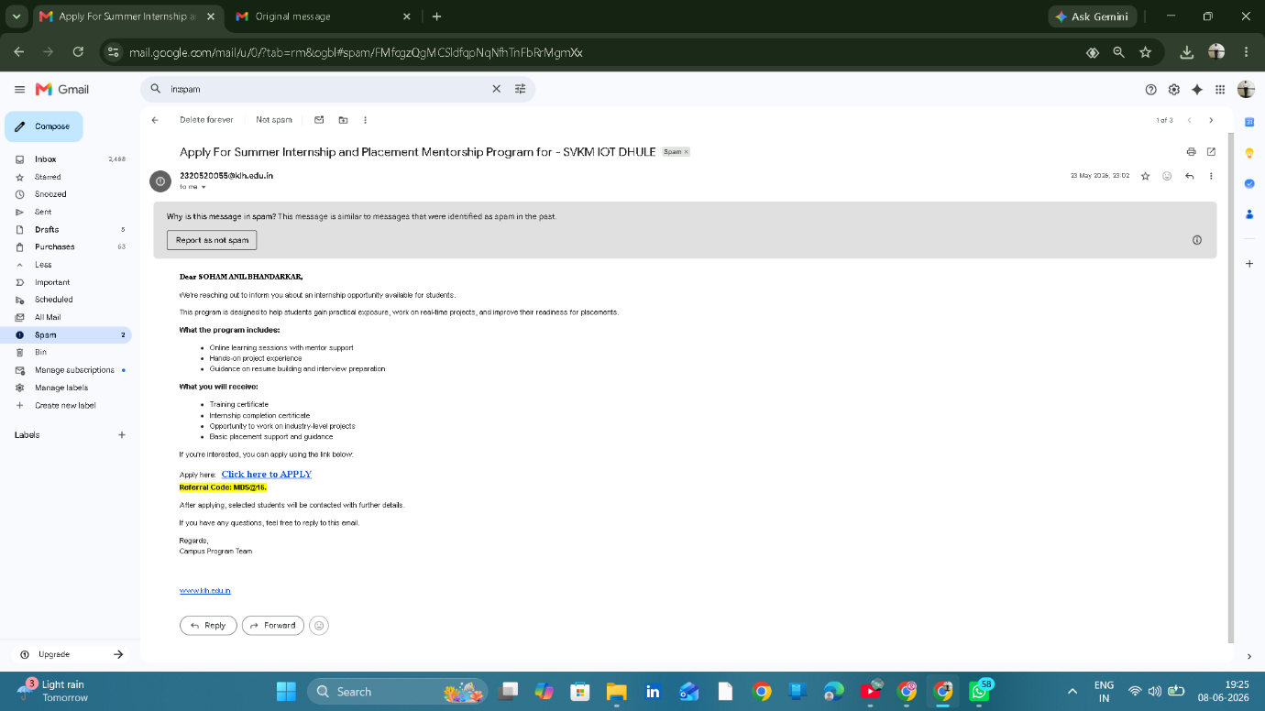

Email Sample 1 – Internship Opportunity Email
Sender: 2320520055@klh.edu.in
Subject: Apply For Summer Internship and Placement Mentorship Program for - SVKM IOT DHULE
Classification: SAFE

Email Sample 1 Header Analysis

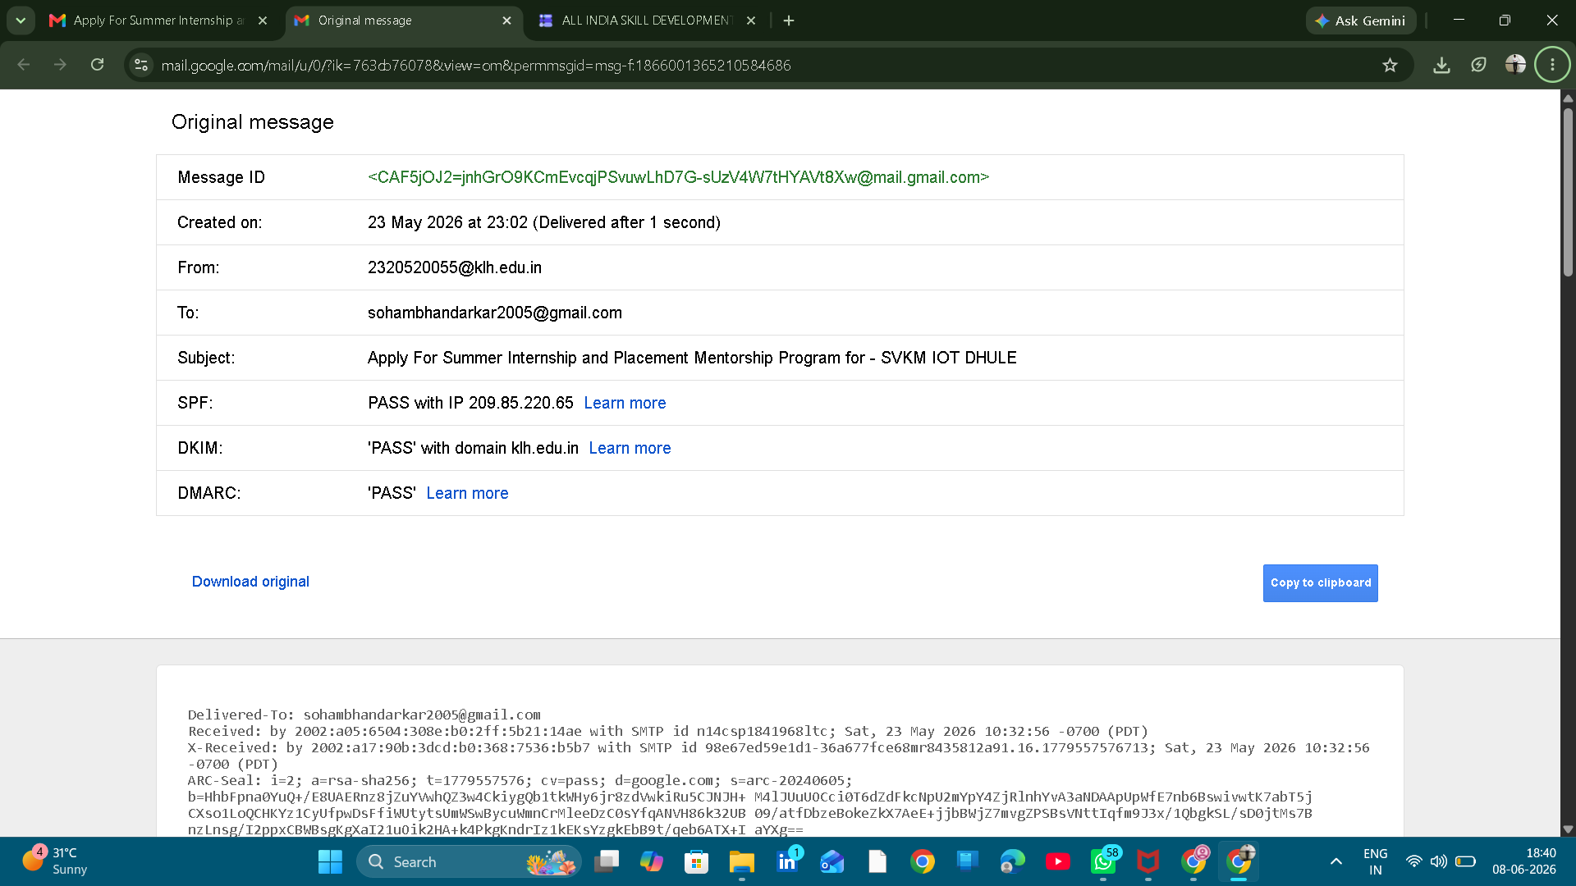
Google Header Analyser Screenshot

Parameter | Result
SPF | PASS
DKIM | PASS
DMARC | PASS
Sender Domain | klh.edu.in
Risk Level | Low

MXToolbox Screenshot
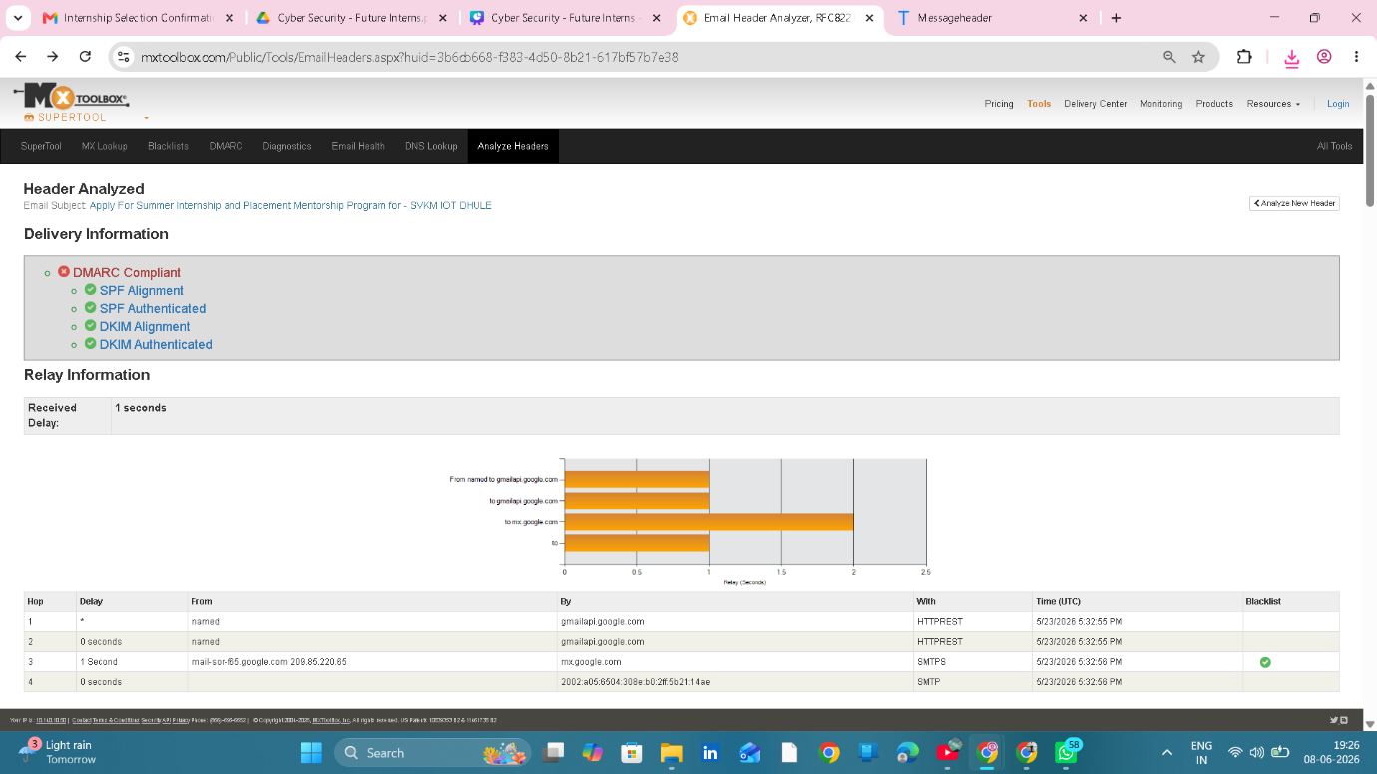

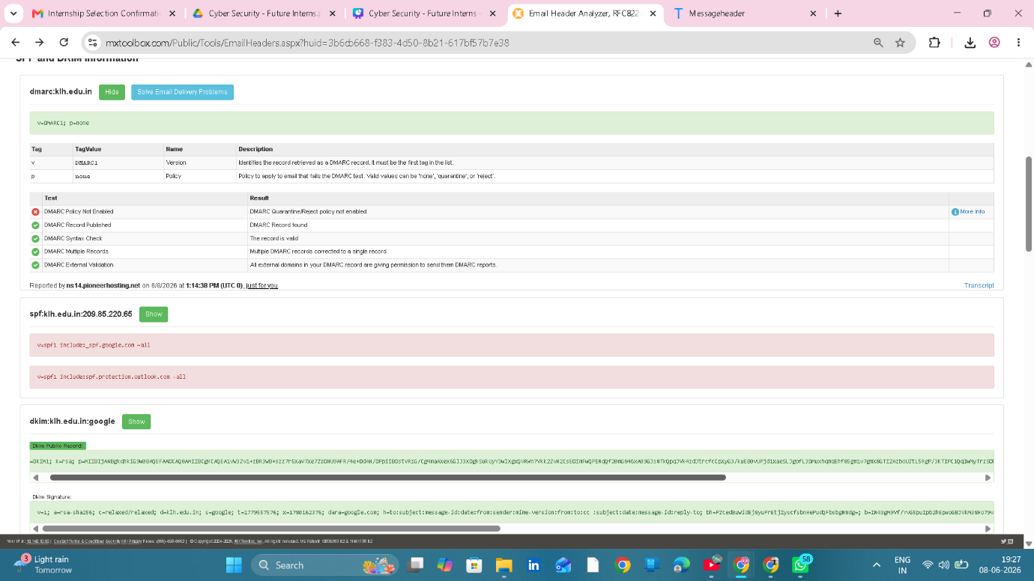

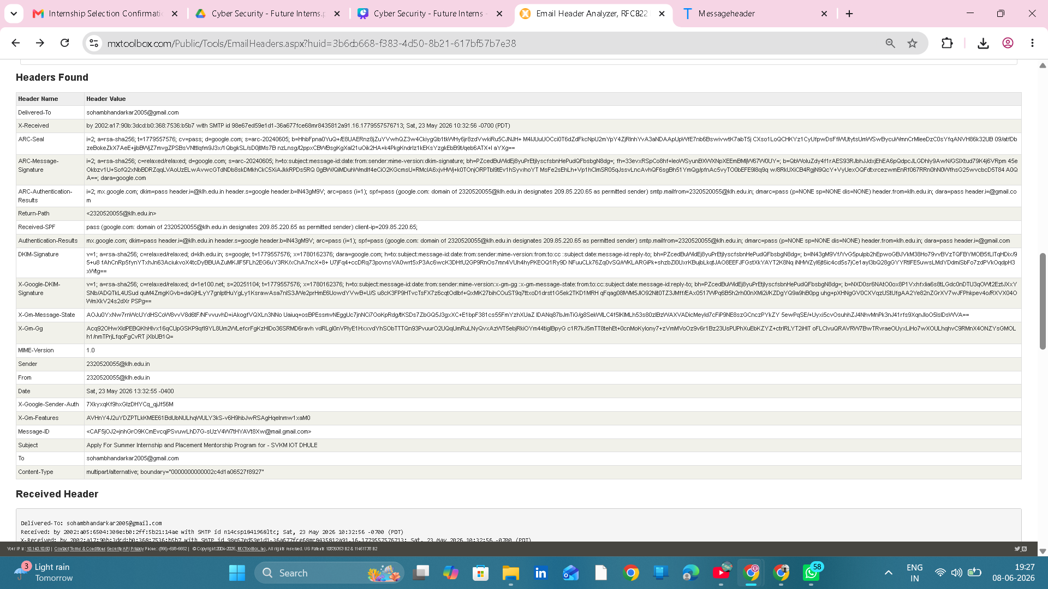

Phishing Indicators Analysis

Indicator | Status
Fake Sender Domain | No
Generic Greeting | No
Urgent Language | No
Password Request | No
OTP Request | No
Suspicious Attachment | No
Suspicious Link | No

Risk Classification
Classification: SAFE

Reason:
• SPF PASS
• DKIM PASS
• DMARC PASS
• Legitimate Domain
• Personalized Greeting
• No urgency or fear tactics

Email Sample 2 Overview

Email Sample 2 – Payment Reminder Email
Sender:sendotp@sendotp.co
Subject:Payment Reminder
Classification: SUSPICIOUS

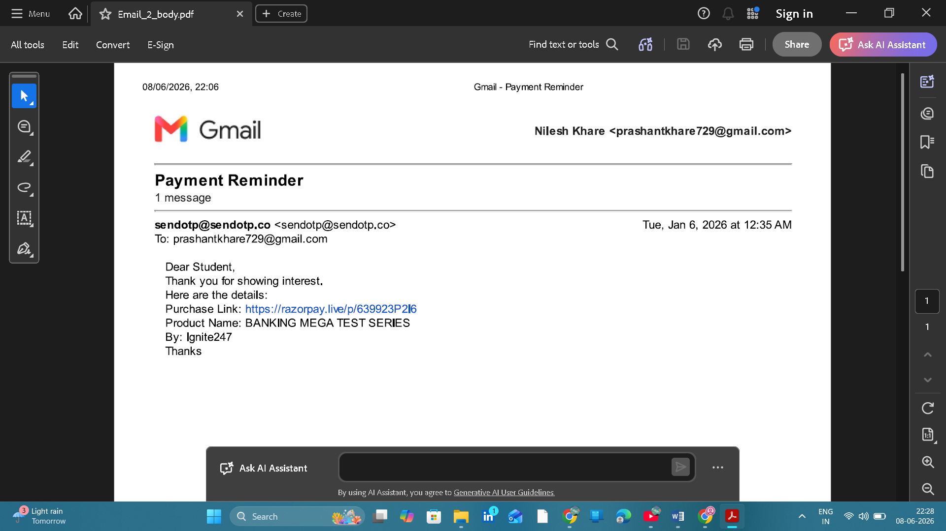

Email body screenshot

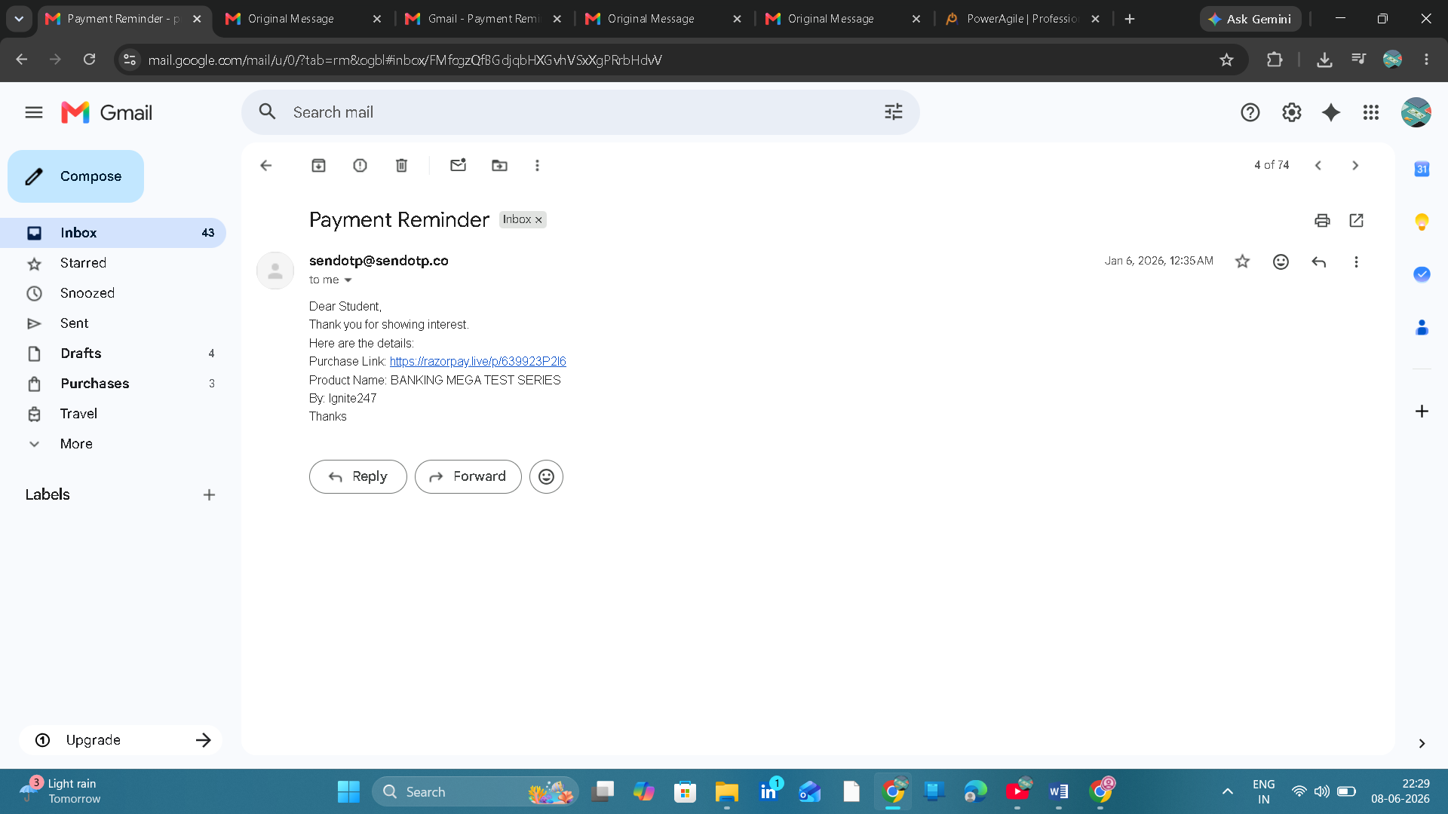
Gmail Original screenshot

Header Analysis
Parameter | Result
SPF | PASS
DKIM | PASS
DMARC | FAIL (No Record Found)
Sender Domain | sendotp.co
Risk Level | Medium

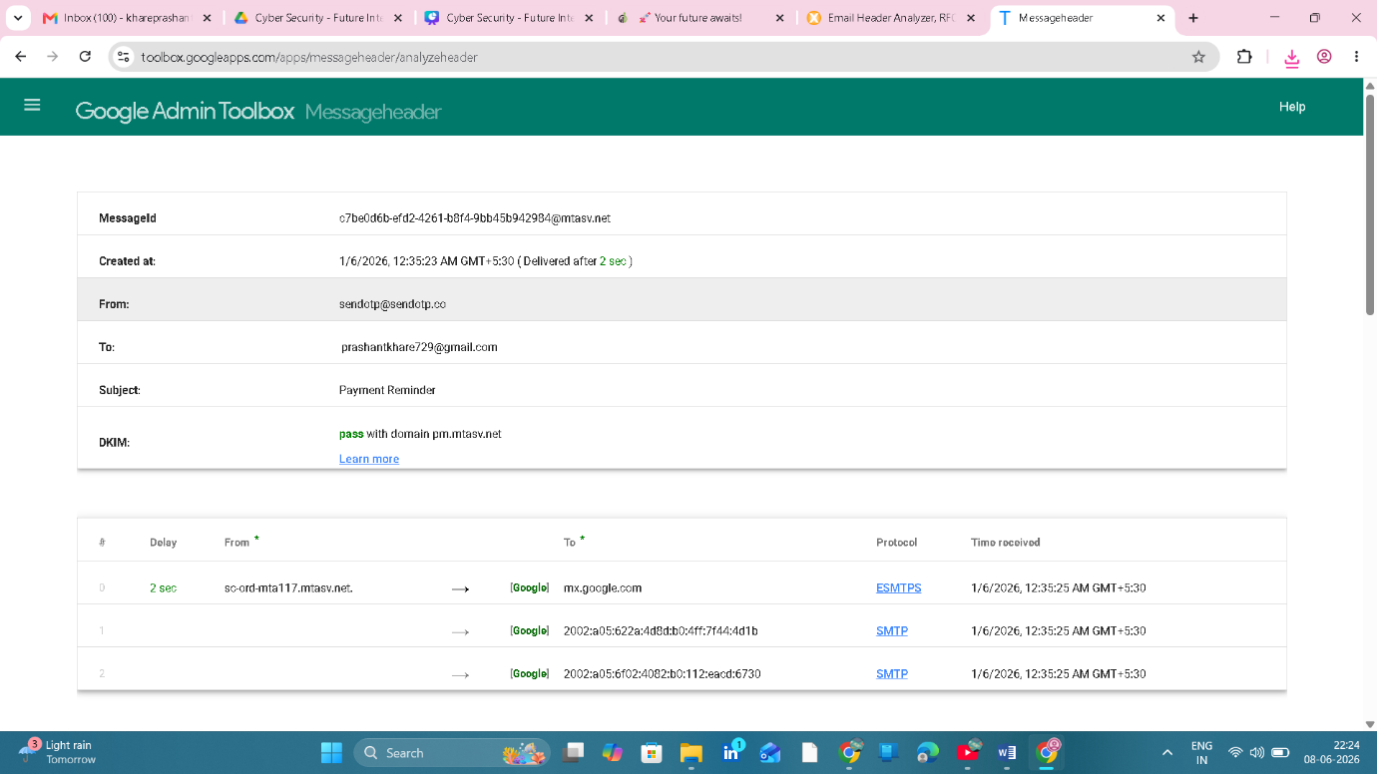
Google Analyzer Screenshot

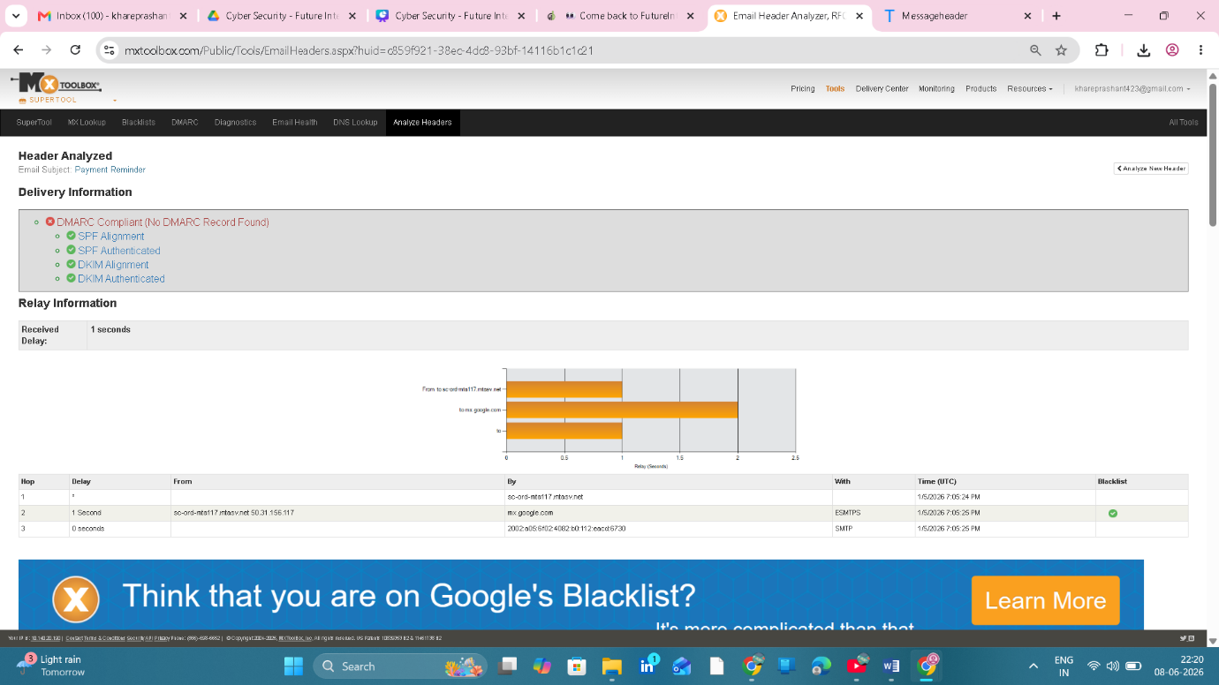

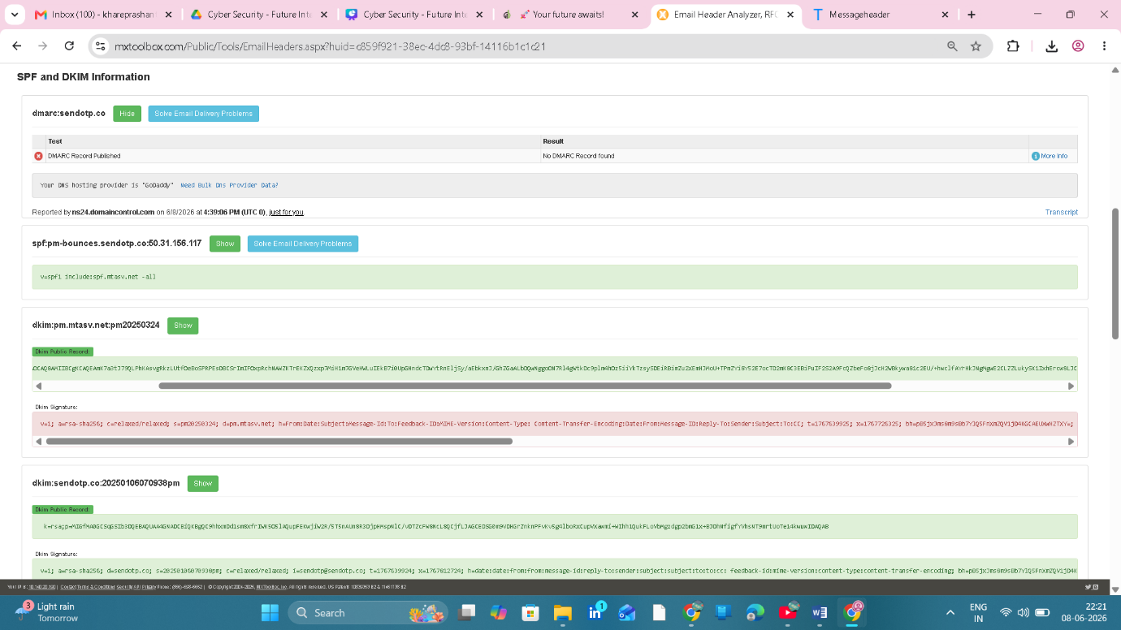
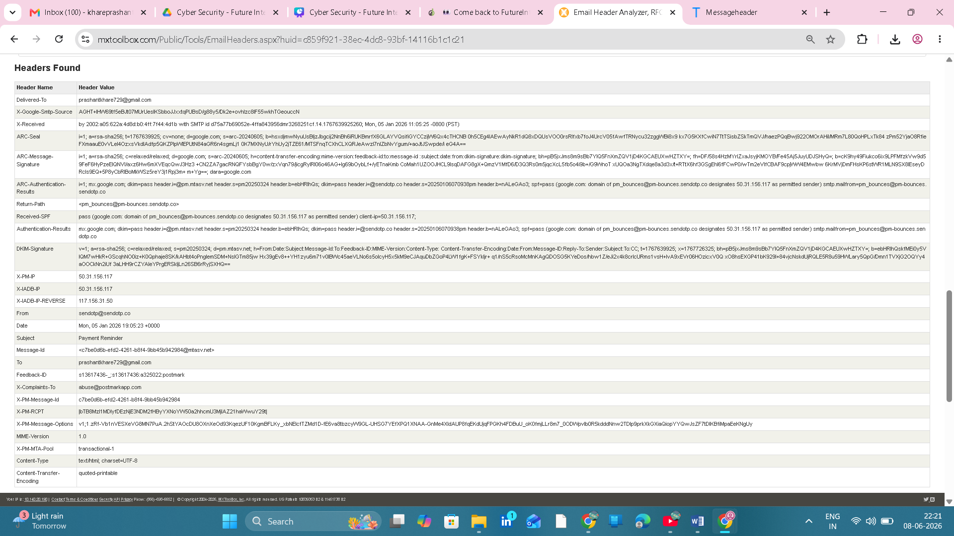
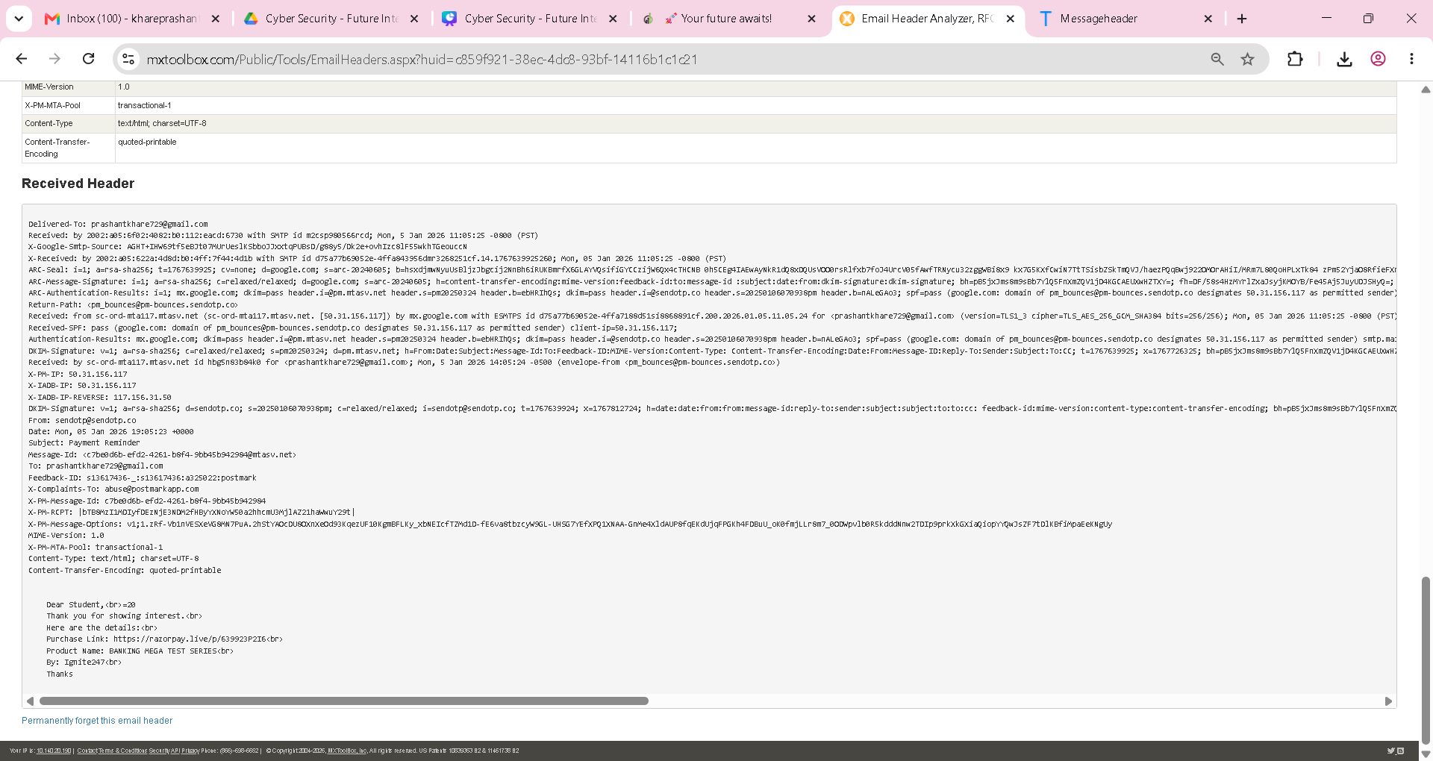
MXToolbox Screensho
t
Phishing Indicators
Indicator | Status
Generic Greeting | Yes
Payment Request | Yes
Suspicious Link | Needs Verification
SPF Failure | No
DKIM Failure | No
DMARC Missing | Yes

Conclusion
The email passed SPF and DKIM authentication checks but no DMARC record was found. The email contains a generic greeting and a payment-related request. Therefore, the email is classified as Suspicious and requires verification before interaction.
Email Sample 3 – Phishing Email Analysis

Field | Value
Subject | Monday, March 7 2022
Sender | attack@attacker.example.com
Email Type | Phishing
Risk Level | High
Classification | Malicious

Evidence Collected
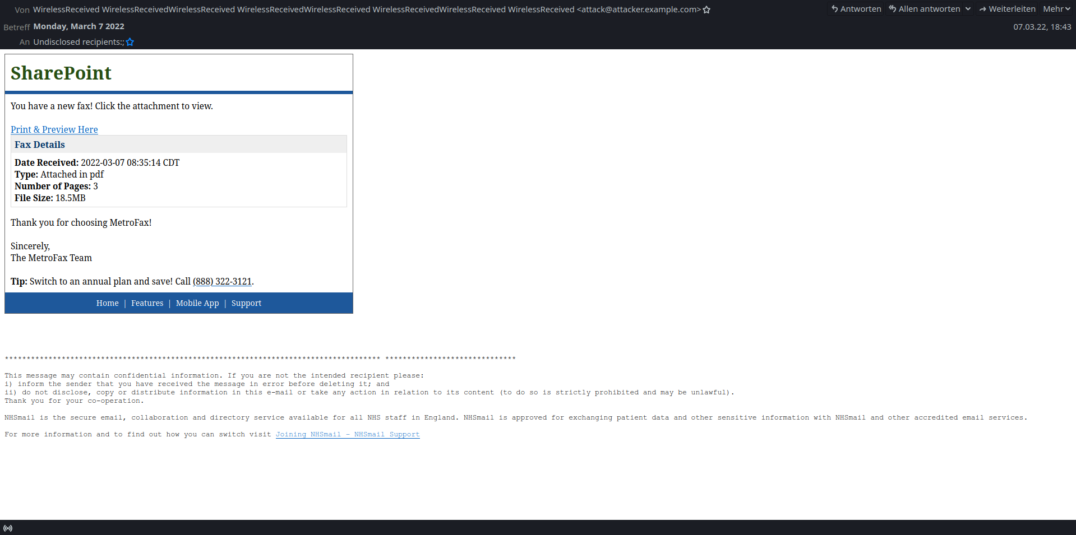
Email3_Phishing_Evidence.png
Description:
The email impersonates SharePoint and claims that a new fax document is available. The message attempts to convince the recipient to open a PDF attachment.

Email Header Analysis

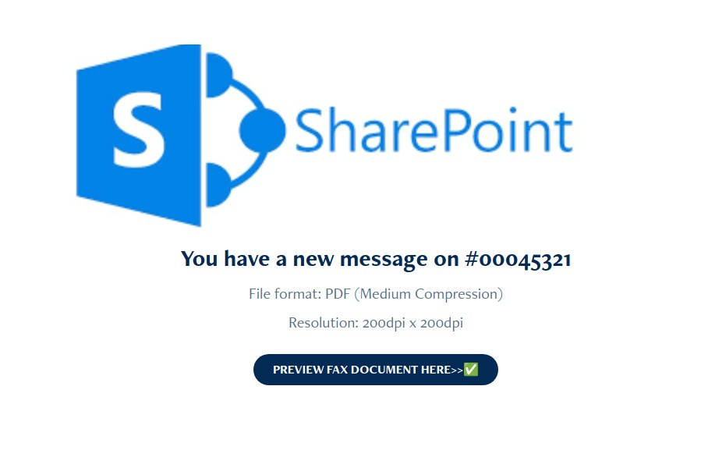
(message.eml)
Key Header Fields:

From: attack@attacker.example.com
Return-Path: attack@attacker.example.com
To: Undisclosed recipients
Subject: Monday, March 7 2022

Identified Phishing Indicators
1. Suspicious Sender Address
attack@attacker.example.com
Finding:
- Sender uses suspicious domain.
- Domain is not associated with Microsoft SharePoint.
- Attempts to impersonate a trusted service.
Risk: High

2. Fake SharePoint Branding
Email displays:
SharePoint
You have a new fax!
Finding:
- Uses SharePoint logo and branding.
- Tries to gain user trust by impersonating a legitimate service.
Risk: High

3. Malicious Link
URL found:
https://attacker.example.com/
Finding:
- Link points to attacker-controlled domain.
- Not an official Microsoft or SharePoint URL.
- Could redirect users to credential theft or malware pages.
Risk: Critical

4. Attachment-Based Social Engineering
Email states:Type: Attached in PDF
Number of Pages: 3
File Size: 18.5 MB
Finding:
- Encourages users to open attachment.
- Common phishing technique used to deliver malware.
Risk: High

5. Generic Recipient
To: Undisclosed recipients
Finding:
- Indicates mass distribution.
- Legitimate business communications generally contain identified recipients.
Risk: Medium

Risk Assessment
Indicator | Severity
Suspicious Sender | High
Fake Branding | High
Malicious URL | Critical
Attachment Lure | High
Bulk Delivery | Medium

Overall Risk Rating:
HIGH RISK PHISHING EMAIL

Analyst Conclusion
The email is a phishing attempt designed to impersonate Microsoft SharePoint and trick users into opening a malicious attachment or visiting a fraudulent website. Multiple phishing indicators were identified, including a suspicious sender address, fake branding, malicious URL, and social engineering tactics.
Final Classification:
PHISHING EMAIL

